
CRO 401589

In recognition of the successful completion of the
Lasertech Truspeed DC and Lastertech Trucam2
device training programme.
- 
Date: 12/05/2026

Instructor name: 406507
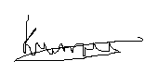
Instructor Signature:_

